Student Name: Priyanka Chandwani UID: 25MCI10122
Branch: M.C.A(A.l & M.L) Section/Group: MAM-1 A
Semester: Second Sem Date of Performance:12/01/2026
Subject Name: TECHINCAL SKILLS Subject Code:

WORKSHEET 8
AIM: To apply the concept of Stored Procedures in database operations in order to perform tasks like insertion, updating, deletion, and retrieval of data efficiently, securely, and in a reusable manner within the database system.
S/W Requirement: Oracle Database Express Edition and pgAdmin
OBJECTIVES:
- To understand the concept and usage of stored procedures in database systems.
- To implement stored procedures for performing CRUD operations efficiently.
- To enhance data security by restricting direct access through stored procedures.
- To reduce code redundancy by using reusable database procedures.
- To improve performance of database operations using precompiled stored procedures.
Practical / Experiment Steps
Tables Creation & Insertion
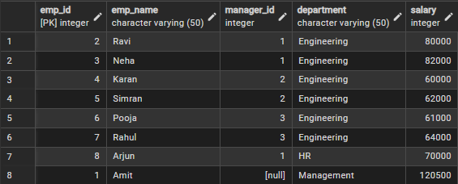

Step 1. Create or replace a procedure for Updating Employee Salaries
create or replace procedure update_salary_proc(IN P_EMP_ID INT,INOUT P_SALARY NUMERIC(20,3),OUT STATUS VARCHAR(20))
AS
$$
DECLARE
CURR_SAL NUMERIC(20,3);
BEGIN

SELECT SALARY+P_SALARY INTO CURR_SAL FROM employees WHERE EMP_ID=P_EMP_ID;
IF NOT FOUND THEN
RAISE EXCEPTION 'EMPLOYEE NOT FOUND';
END IF;

UPDATE employees
set salary= curr_sal
where emp_id=p_emp_id;

P_salary:=curr_sal;
status:='SUCCESS';

EXCEPTION
WHEN OTHERS THEN
IF SQLERRM LIKE '%EMPLOYEE NOT FOUND%' THEN
STATUS:= 'EMPLOYEE NOT FOUND';
END IF;

END;

$$ LANGUAGE PLPGSQL;

Step 2 Calling of Stored Procedure

DO
$$
DECLARE
EMP_ID INT:=1;
STATUS VARCHAR(20);
SALARY NUMERIC(20,3):=500;
BEGIN
CALL update_salary_proc(Emp_id,salary,status);
RAISE NOTICE 'YOUR STATUS IS % AND YOUR UPDATED SALARY IS %',STATUS,salary;
END;
$$

Output:

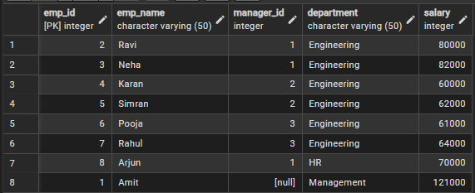
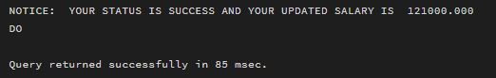

Outcomes:
- To demonstrate the ability to create and execute stored procedures for various database operations.
- To apply stored procedures for performing secure and efficient CRUD operations.
- To analyze the impact of stored procedures on database performance and execution efficiency.
- To design modular and reusable database logic using stored procedures.

